ST ANDREW’S UNITED REFORMED CHURCH, WALTON AND WEYBRIDGE


Sunday 6th September 2026
Morning Worship
with Holy Communion
led by Stephen Thornton

WE EXTEND THE WARMEST OF WELCOMES
TO ALL VISITORS
New to the Church? Do make yourself known to us!

Prayer before services: some useful personal prayers are to be found on the inside front cover of the hymnbook.

“Do not spoil what you have by desiring what you have not; remember that what you now have was once among the things you only hoped for.”
― Epicurus (Greek philosopher 341-270 BCE)

The flowers in the Church this week have been given by Jean Rigden with love for Eric.

Order of Service

Welcome & Notices

Peace Candle

Call to Worship

Hymn 125 Ye holy angels bright

Introduction to Theme

Reading Ecclesiasticus 44:1-15 (Page 102 Ap)

Prayer & Lord's Prayer

Hymn 566 The Church's one foundation

Reading 1 Peter 2:1-10 (Page 216 NT)

Sermon

Hymn 370 Soldiers of Christ!

Introduction to Communion

Hymn 364 Just as I am

Communion

Prayers

Hymn 658 For all the saints

Benediction and sung Amen
Service Diary

Sunday 13th September 10:30 Morning Worship
Led by Katrina Clifford

Sunday 20th September 10:30 Morning Worship
Led by David Paterson

Sunday 27th September 10:30 Morning Worship
Led by Mark Dennis
Followed by a Church Meeting

Sunday 4th October 10:30 Morning Worship
With Holy Communion
Led by Mark Dennis


Mini Grapevine

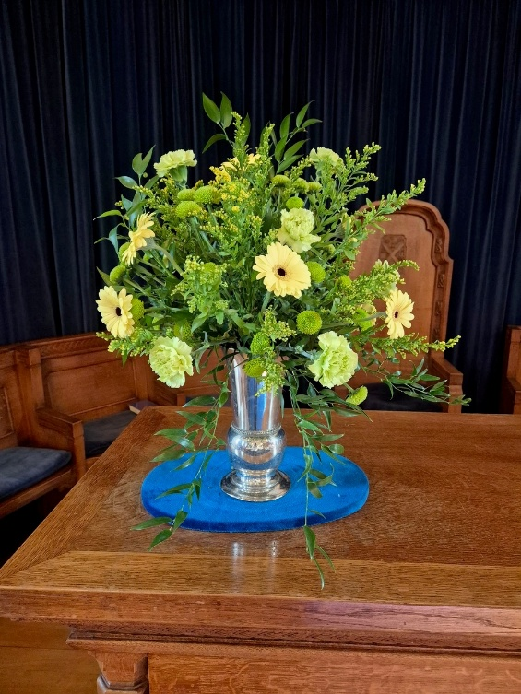
The flowers in the Church last Sunday were given by Caroline Gardner for her brother.

ArtPeace and Friends
Hard copies of the September article are now available in The Gateway. A colourful issue featuring the usual mix of stories showing the resilience of Zimbabweans where protest against an uncaring government is futile.

People who Lunch
People who Lunch returns on 11th September. It’s a great opportunity to meet with friends. If you’d like to come, it’s helpful to the team if you can book your space in advance so that they know how many people to cater for. To book, please email Elizabeth of administrator@standrewsurc.org or call Fiona on: mobile: 07902485933 or landline: 01932247119

Treble Clef Choir

Gwenda and Hilary are both members of the Treble Clef Choir and have some tickets for this event on 9th October. Please see one of them if you are interested.

