ST ANDREW’S UNITED REFORMED CHURCH, WALTON AND WEYBRIDGE


Sunday 4th October 2026
Morning Worship with
Holy Communion
led by Mark Dennis

WE EXTEND THE WARMEST OF WELCOMES
TO ALL VISITORS
New to the Church? Do make yourself known to us!

Prayer before services: some useful personal prayers are to be found on the inside front cover of the hymnbook.

The flowers today have been given by Anne Fitzgerald for David’s birthday

Order of Service

Lighting of the Peace Candle

Call to Worship

Hymn RS 94 Give to our God immortal praise (Tune: Duke Street)

Prayer of praise; the Lord’s Prayer

Family Time

First reading: Acts 1: 1-5 (Page 109 NT)

Hymn RS 195 I danced in the morning
(Tune: Shaker tune)

Second reading: Mark 1: 14-45 (Page 32 NT)

Sermon ‘Mark’s gospel: Jesus begins his ministry’
Hymn RS 355 Jesus calls us! O’er the tumult (Tune: Cross of Jesus)

Invitation to Communion

Hymn RS 447 I come with joy to meet my Lord
(Second tune: St Botolph)

Celebration of Holy Communion

Hymn RS 200 The kingdom of God
(Tune: Hanover (RS 47))

Blessing; sung ‘Amen’

Exit of Bible

-------------------------------------------------------------------

Service Diary

Sunday 11th October 10:30 Morning Worship
Harvest Festival Parade
Led by Ray Stanyon

Sunday 18th October 10:30 Morning Worship
Led by Anna Crawford

Sunday 25th October 10:30 Morning Worship
Led by Bill Bowman

Sunday 1st November 10:30 Morning Worship
With Holy Communion
Led by Vivien Gerhold and
Ray Stanyon


Mini Grapevine


The flowers in the Church on Sunday 13th September, were given by Irene Pearson in memory of Jeff. It would’ve been their 60th wedding anniversary.


The October edition of the newsletter is available today in the hall. Please do take a copy and stay up to date with our friends in Zimbabwe. If you would like to be added to the email circulation list to receive the newsletter electronically, please speak to Johnston.

People who Lunch – Friday 9th October

The next People who Lunch will be held on Friday 9th October at 12.30pm. If you enjoy meeting with friends or even meeting new ones, this is the perfect social event for you! If you would like to attend, please email Elizabeth on
administrator@standrewsurc.org or call Fiona Reardon on:
mobile: 07902485933 or landline: 01932247119


Harvest – Sunday 11th October

Next Sunday is our Harvest Festival when we will be joined by Revd Ray Stanyon and our uniformed organisations.
As usual, we will be collecting donations for the Walton and Hersham Foodbank.
Their most needed items at the moment are:

- Breakfast cereal and long-life milk
- Tinned meat / fish
- Tinned macaroni / spaghetti
- Crisps and savoury snacks
- Jam / peanut butter
- Instant noodles
- Instant coffee / hot chocolate / tea bags
- Mayonnaise
- Chocolate and sweets
- Long-life sponge puddings and custard
- Deodorant
- Shaving gel / foam
- Washing up liquid and kitchen roll
- Feminine hygiene products

For more information about the Foodbank or to make a monetary donation, please visit:
www.waltonhersham.foodbank.org.uk

At harvest time when we remember those who provide the food we eat and give thanks for it, here is an ancient prayer to help us remember that we should give thanks for all we have.

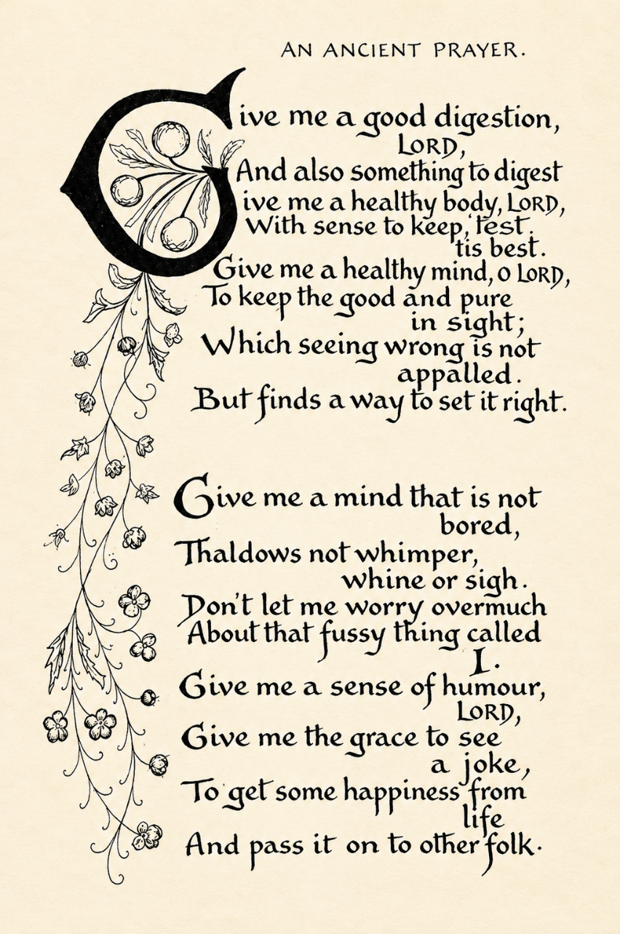

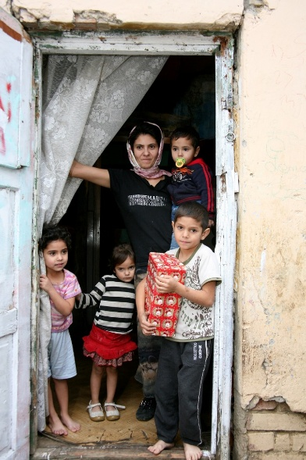

As in previous years, we will, once again, be supporting the Link to Hope appeal. The Link to Hope Shoebox Appeal 2026 brings practical help, dignity, and hope to families and elderly people living in poverty across Ukraine and Eastern Europe — not just children. We ask that you fill a shoebox with a carefully selected mix of practical and thoughtful items for all family members, including toiletries, stationery, family games, gifts for mum and dad, sweets, soft toys, and seasonal essentials such as hats and scarves. These boxes will be collected at our service on 25th October.
Please help transform lives across Ukraine and Eastern Europe — one shoebox at a time!

Ashley Park School Coffee Mornings

This event is taking place again on 13th October and is open to anyone from the community. Please do come along and support them 10.15am and 11.15am. The money that they raise will goes to the Heathrow Special Needs Centre which is a charity committed to enhancing the lives of individuals of all ages with disabilities and special needs.

You can also follow us on Facebook:
https:www.facebook.com/standrewsurcww

All Church information can also be found on our website:
www.standrewsurc.org

Interim Moderator: The Revd Peter Flint

FOR ANY ENQUIRIES PLEASE CONTACT THE CHURCH ADMINISTRATOR

