ST ANDREW’S UNITED REFORMED CHURCH, WALTON AND WEYBRIDGE

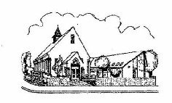
Sunday 30th 2026
Morning Worship
led by David Paterson

WE EXTEND THE WARMEST OF WELCOMES
TO ALL VISITORS
New to the Church? Do make yourself known to us!

Prayer before services: some useful personal prayers are to be found on the inside front cover of the hymnbook.

The flowers in the Church this week have been given by Caroline Gardner for her brother.

Today we welcome David Paterson. David is South African and is married to Sharon. He belongs to Walton Methodist Church and is a lay preacher on the Methodist Circuit. He may be known to some of the congregation as he and Sharon were valued volunteers at the Contact Centre here in St Andrew’s.

Order of Service

Light the Peace Candle
Call to worship
Hymn 67 Immortal, invisible, God only wise
Opening prayers followed by the Lord’s Prayer
Family Time
Bible Reading Matthew 16: 21-28 (Page 17 NT)
Hymn Blessed assurance (Overleaf)
Sermon
Hymn When peace like a river attendeth my way (it is well with my soul) (Overleaf)
Prayers of Intercession
Hymn 117 O Lord my God, when I in awesome wonder (How great thou art)
Blessing followed by a sung Amen
Exit of the Bible

Blessed assurance, Jesus is mine:
O what a foretaste of glory divine!
Heir of salvation, purchase of God;
born of His Spirit, washed in His blood.

This is my story, this is my song,
praising my Saviour all the day long;
this is my story, this is my song,
praising my Saviour all the day long.

Perfect submission, perfect delight,
visions of rapture burst on my sight;
angels descending, bring from above
echoes of mercy, whispers of love.

This is my story…..

Perfect submission, all is at rest,
I in my Saviour am happy and blest;
watching and waiting, looking above,
filled with His goodness, lost in His love,

This is my story…..

When peace like a river attendeth my way,
when sorrows like sea-billows roll;
whatever my lot You have taught me to say,
‘It is well, it is well with my soul.’

It is well with my soul;
It is well, it is well with my soul.

Though Satan should buffet, if trials should come,
let this blessed assurance control,
that Christ has regarded my helpless estate,
and has shed His own blood for my soul.

It is well with my soul….

My sin- O the bliss of this glorious thought
my sin – not in part- but the whole
is nailed to His cross; and I bear it no more;
praise the Lord, praise the Lord, O my soul.

It is well with my soul….

For me, be it Christ, be it Christ hence to live!
If Jordan above me shall roll,
no pang shall be mine, for in death as in life
You will whisper Your peace to my soul.

It is well with my soul….

But Lord, it’s for You – for Your coming we wait,
The sky, not the grave, is our goal:
O trump of the angel! O voice of the Lord!
Blesséd hope! Blesséd rest of my soul.

It is well with my soul….

Service Diary

Sunday 6th September 10:30 Morning Worship
With Holy Communion
Led by Stephen Thornton

Sunday 13th September 10:30 Morning Worship
Led by Katrina Clifford

Sunday 20th September 10:30 Morning Worship
Led by David Paterson

Sunday 27th September 10:30 Morning Worship
Led by Mark Dennis


Mini Grapevine

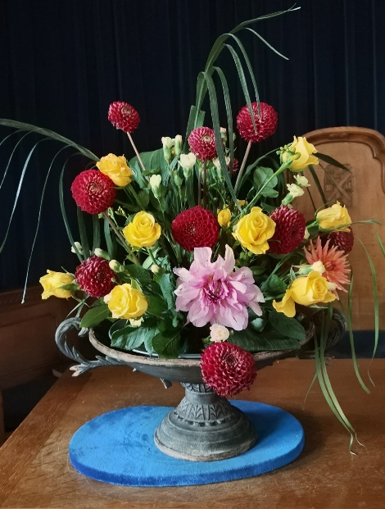
The flowers in the Church last Sunday were given by Rosemary Topping for her 60th Anniversary.

Treble Clef Choir

Gwenda and Hilary are both members of the Treble Clef Choir and have some tickets for this event on 9th October. Please see one of them if you are interested.

Eco Church is 10 years old this year!

A Rocha, the Christian charity that runs the Eco Church scheme, have recently released a report about the success of the Eco Church scheme in the 10 years that it has been running. A very brief over view from the report is below:

Eco Church at a glance
Since Eco Church launched:
- 9000+ churches have registered
- 4,700+ churches have received an Eco Church award
- 3,100+ churches have achieved Bronze
- 1,500+ churches have achieved Silver
- 120+ churches have achieved Gold

To view the full A Rocha report, please ask Elizabeth Scharinger to email you the link.

As a Church that has been awarded bronze, one thing for St Andrews to take from the report is what it says about how to get to Silver:

“To get from Bronze to Silver, churches primarily need to focus on the Lifestyle category, although significant progress is also needed in Land, Buildings and Energy, and Community and Global Engagement…..This is the point at which motivating the wider church becomes essential: progress in these areas is impossible without significant commitment from the congregation”

After the summer we've just had, perhaps many of us have been thinking more seriously about the changing climate and the future of our planet. It is easy to feel that the problem is simply too big and that there is little one person can do. But caring for creation does not have to mean turning our whole lives upside down. Perhaps caring for God's world is not always about doing something completely new, but about remembering some old ways and passing on to the generations who follow us.
Use less energy where we can
Turn off lights and appliances when they are not needed, avoid leaving electrical items on standby, and think about ways of keeping our homes warm in winter without wasting energy.
Buy less and make things last or visit the Repair Café!
Repairing, reusing and passing things on rather than simply replacing them can reduce waste and save money too.
Think about how we travel
Where possible, could we walk, use public transport, share lifts or combine several journeys into one? We don't all need to give up our cars, but even occasional changes can help.
Waste less food
Planning meals, using leftovers and freezing food before it goes off are simple ways to reduce waste. It’s common sense.
Consider what we buy
Before buying something new, it can be worth asking: Do I really need this? Could I borrow it? Could I buy it second-hand? Choosing items with less packaging can also reduce waste.

