ST ANDREW’S UNITED REFORMED CHURCH, WALTON AND WEYBRIDGE

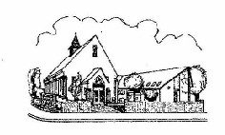
Sunday 27th September 2026
Morning Worship
led by Mark Dennis

WE EXTEND THE WARMEST OF WELCOMES
TO ALL VISITORS
New to the Church? Do make yourself known to us!

Prayer before services: some useful personal prayers are to be found on the inside front cover of the hymnbook.

“Making your Christmas cake in September is perfect, as too fresh a cake crumbles when cut.”
- Mary Berry

The flowers today have been given by Caroline Gardner in memory of Charles

Order of Service

Lighting of the Peace Candle

Call to Worship

Hymn RS 191 Songs of thankfulness and praise
(Tune: St George’s Windsor (RS 40)

Prayer of praise; the Lord’s Prayer

Family Time

Old Testament reading: Isaiah 40: 3-5 (Page 607 OT)

Hymn RS 103 Praise to the Holiest in the height
(2nd tune: Gerontius)

New Testament reading: Mark 1: 1-13 (Page 32 NT)

Hymn RS 321 Your words to me are life and health
Sermon: Introducing Mark

Hymn RS 192 Thou didst leave thy throne

Blessing; sung ‘Amen’

Exit of Bible

Service Diary

Sunday 4th October 10:30 Morning Worship
With Holy Communion
Led by Mark Dennis

Sunday 11th October 10:30 Morning Worship
Harvest Festival Parade
Led by Ray Stanyon

Sunday 18th October 10:30 Morning Worship
Led by Anna Crawford

Sunday 25th October 10:30 Morning Worship
Led by Bill Bowman

Church Meeting Agenda

Opening Prayer

Apologies

Minutes of meeting held on 19 April 2026

Matters arising

Update on Ministerial Vacancy

Update on recent break-in and repairs

Other developments concerning church premises

Safeguarding

Autumn and Christmas Services, and related charity collections

Future of Zoom services

Notices

AOB


Mini Grapevine

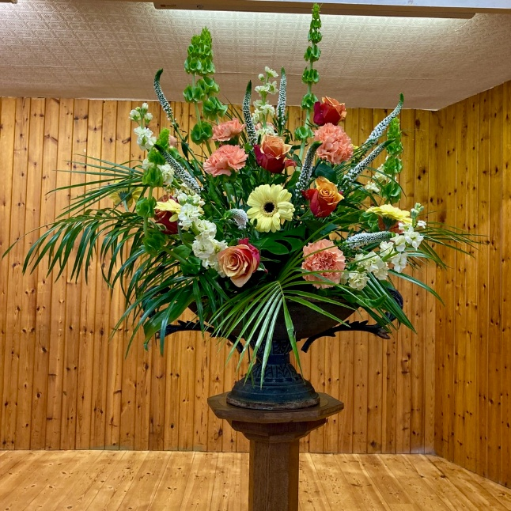
The flowers last Sunday were given by Valerie Dow and Fiona Reardon in memory of their father, David
Happy Anniversary to our Peace Candle

National Emergency Briefing

If you haven’t seen this very important film, there is a screening in Woking at St Dunstan’s Church 19.30 pm on 6th September.

The National Emergency Briefing film is part of a UK-wide public information programme designed to clearly communicate the risks of climate and nature breakdown. It builds on a major expert briefing delivered on 27 November 2025 to more than 1,200 MPs and national leaders.

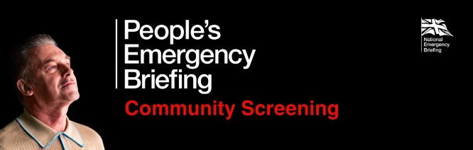

Happy Anniversary to our Peace Candle

It is 25 years since we first lit a Peace Candle at the beginning of the service. This is a brief story of why we do it.

On 11th September, 2001, the Twin Towers of the World Trade Centre in New York were brought down, causing 2,996 to die and at least 6,000 to be injured.

The following Sunday, the Weybridge minister, Rev. Don Macalister, started the service by lighting a candle. He had been so shocked and overwhelmed by the incident that he felt that we, as a church, had to do something. He knew that nothing could be done directly to help those affected, but, by lighting the candle, we could have a focus to pray for peace.

We started twenty-five years ago and, in spite of the many bad things that are still happening in the world, we are still doing so. To quote John, chapter 1, verse 5: “The light shines in the darkness and the darkness did not overcome it.
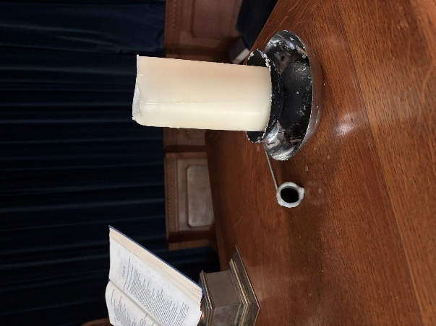

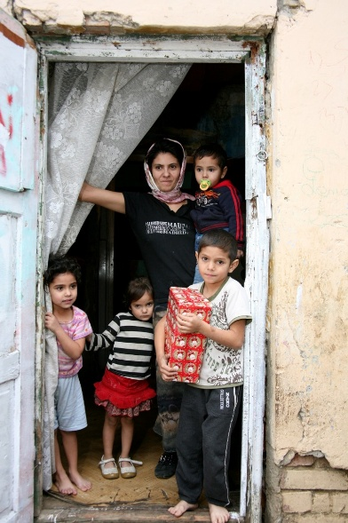

As in previous years, we will, once again, be supporting the Link to Hope appeal. The Link to Hope Shoebox Appeal 2026 brings practical help, dignity, and hope to families and elderly people living in poverty across Ukraine and Eastern Europe — not just children. We ask that you fill a shoebox with a carefully selected mix of practical and thoughtful items for all family members, including toiletries, stationery, family games, gifts for mum and dad, sweets, soft toys, and seasonal essentials such as hats and scarves. These boxes will be collected at our service on 25th October.
Please help transform lives across Ukraine and Eastern Europe — one shoebox at a time!

Ashley Park School Coffee Mornings

This event is taking place again on 13th October and is open to anyone from the community. Please do come along and support them 10.15am and 11.15am. The money that they raise will goes to the Heathrow Special Needs Centre which is a charity committed to enhancing the lives of individuals of all ages with disabilities and special needs.

You can also follow us on Facebook:
https:www.facebook.com/standrewsurcww

All Church information can also be found on our website:
www.standrewsurc.org

Interim Moderator: The Revd Peter Flint

FOR ANY ENQUIRIES PLEASE CONTACT THE CHURCH ADMINISTRATOR

