ST ANDREW’S UNITED REFORMED CHURCH, WALTON AND WEYBRIDGE


Sunday 20th September 2026
Morning Worship
led by David Paterson

WE EXTEND THE WARMEST OF WELCOMES
TO ALL VISITORS
New to the Church? Do make yourself known to us!

Prayer before services: some useful personal prayers are to be found on the inside front cover of the hymnbook.

“Music is moral law. It gives a soul to the Universe, wings to the mind, flight to the imagination, a charm to sadness, gaiety and life to everything.”

- Plato (ancient Greek Philosopher and student of Socrates 427 - 347 BCE

The flowers today have been given by Valerie Dow and Fiona Reardon in memory of their father David.

Order of Service

Light the Peace Candle
Call to worship
Hymn 96 Great is thy faithfulness
Opening prayers followed by the Lord’s Prayer
Family Time
Bible Reading: Revelation 2: 1-7 (Page 228 NT)
Hymn 512 Seek he first the kingdom of God

Bible Reading: Matthew 20: 1-16 (Page 20 NT)
Sermon
Hymn 474 Brother, Sister Let me serve you

Prayers of Intercession
Hymn (Overleaf) As the deer pants for the water
Blessing followed by a sung Amen
Exit of the Bible

As the deer pants for the water
So my soul longs after You
You alone are my heart’s desire
And I long to worship You.
You alone are my strength, my shield
To You alone may my spirit yield
You alone are my heart’s desire
And I long to worship You.
I want you more than gold or silver
Only You can satisfy
You alone are the real joy giver
And the apple of my eye.
You alone are my strength, my shield
To You alone may my spirit yield
You alone are my heart’s desire
And I long to worship You.
You're my friend and You're my brother
Even though you are a King
I love You more than any other
So much more than anything.
You alone are my strength, my shield
To You alone may my spirit yield
You alone are my heart’s desire
And I long to worship You.

Service Diary

Sunday 27th September 10:30 Morning Worship
Led by Mark Dennis
Followed by a Church Meeting

Sunday 4th October 10:30 Morning Worship
With Holy Communion
Led by Mark Dennis

Sunday 11th October 10:30 Morning Worship
Harvest Festival Parade
Led by Ray Stanyon

Sunday 18th October 10:30 Morning Worship
Led by Anna Crawford

Church Meeting – Sunday 27th September

Those who have email, should have received a copy of the minutes from the meeting on 19th April. If you haven’t received them, please contact Elizabeth on:
administrator@standrewsurc.org.
There are some hard copies in The Gateway.


Mini Grapevine

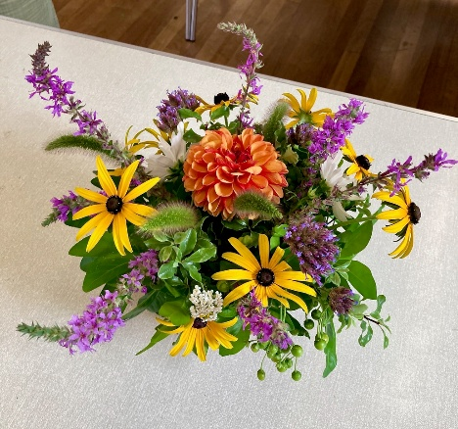
This is a picture of the flower arrangement that Norma did at the Flower Club summer workshop on 6th August.

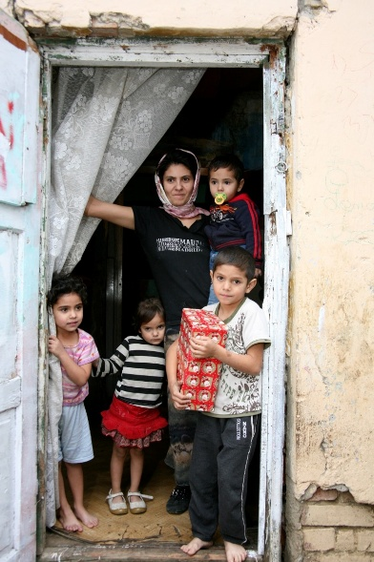

As in previous years, we will, once again, be supporting the Link to Hope appeal. The Link to Hope Shoebox Appeal 2026 brings practical help, dignity, and hope to families and elderly people living in poverty across Ukraine and Eastern Europe — not just children. We ask that you fill a shoebox with a carefully selected mix of practical and thoughtful items for all family members, including toiletries, stationery, family games, gifts for mum and dad, sweets, soft toys, and seasonal essentials such as hats and scarves. These boxes will be collected at our service on 25th October.
Please help transform lives across Ukraine and Eastern Europe — one shoebox at a time!

Ashley Park School Coffee Mornings

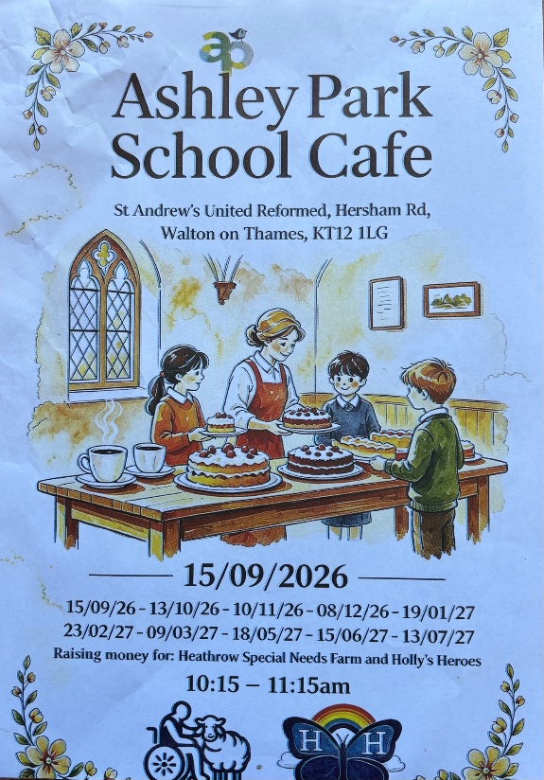
The first of these new coffee mornings went well this week. Jem and Liz both attended to show the support of St Andrews and to help out. In total there were about 12 people, including families and friends of pupils at the school.
The pupils had brought some bunting and put it on the garden railing, which was effective and will hopefully help in attracting passers by for future coffee mornings.
This event is going to take place monthly and is open to anyone from the community. Please do come along and support them on 13th October between 10.15am and 11.15am.

ArtPeace and Friends
Hard copies of the September article are now available in The Gateway. A colourful issue featuring the usual mix of stories showing the resilience of Zimbabweans where protest against an uncaring government is futile.

Last Sunday, after a challenging few weeks for the Church, Katrina Clifford asked us all to write our prayers on a ‘brick’ so that together, we could ‘build a house where love can dwell’
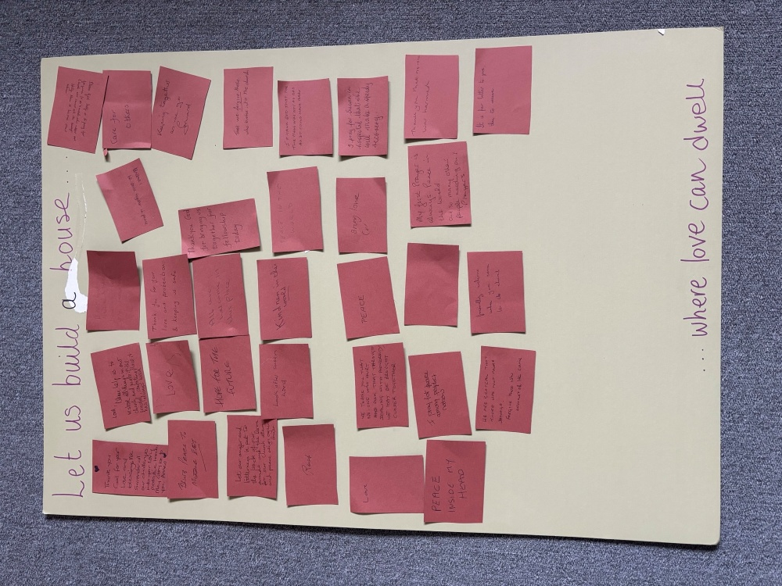
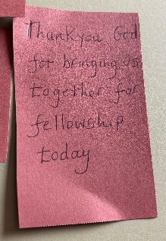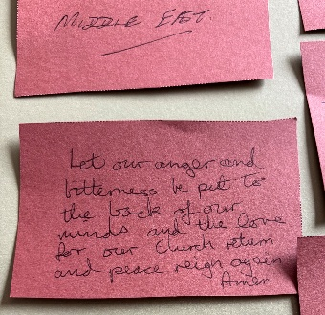

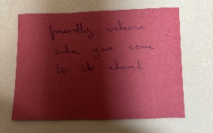
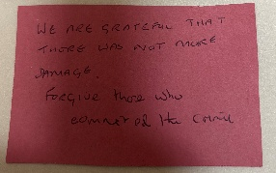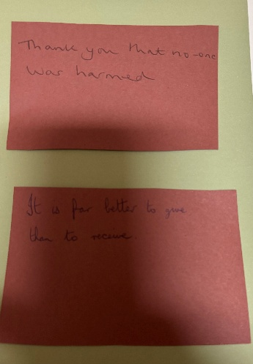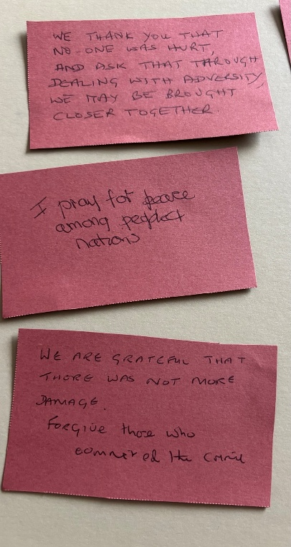

You can also follow us on Facebook:
https:www.facebook.com/standrewsurcww

All Church information can also be found on our website:
www.standrewsurc.org

Interim Moderator: The Revd Peter Flint

FOR ANY ENQUIRIES PLEASE CONTACT THE CHURCH ADMINISTRATOR

