ST ANDREW’S UNITED REFORMED CHURCH, WALTON AND WEYBRIDGE

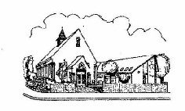
Sunday 13th September 2026
Morning Worship
led by Katrina Clifford

WE EXTEND THE WARMEST OF WELCOMES
TO ALL VISITORS
New to the Church? Do make yourself known to us!

Prayer before services: some useful personal prayers are to be found on the inside front cover of the hymnbook.

“Do not spoil what you have by desiring what you have not; remember that what you now have was once among the things you only hoped for.”
― Epicurus (Greek philosopher 341-270 BCE)

The flowers today have been given by Irene Pearson in memory of Jeff

Order of Service

Welcome and Notices

Call to worship

Lighting of the peace candle

Rededication activity with prayer

Hymn Let us build a house (Matty Haugen b.1950)

Prayers of adoration and confession

Assurance of forgiveness and Lord’s Prayer

Family time

Hymn It’s me, it’s me oh Lord
(African- American Spiritual)

Bible Reading 1: Luke 18: 1-8 (Page 75 NT)
Bible Reading 2: Genesis 32: 22-31 (Page 28 OT)

Sermon

Pause for reflection

Hymn R&S 413 What a friend we have in Jesus

Prayers of concern

Offertory moment

Hymn R&S 76 The Lord is King! Lift up your voice

Blessing and dismissal/ Sung Amen
Let us build a house where love can dwell
and all can safely live,
a place where saints and children tell
how hearts learn to forgive:
built of hopes and dreams and visions,
rock of faith and vault of grace:
here the love of Christ shall end divisions:
All are welcome
All are welcome,
All are welcome in this place.
Let us build a house where prophets speak,
and words are strong and true,
where all God’s children dare to seek
to dream God’s reign anew.
Here the cross shall stand as witness
and as symbol of God’s grace;
here as one we claim the faith of Jesus:
All are welcome…
Let us build a house where love is found
in water, wine and wheat:
a banquet hall on holy ground,
where peace and justice meet.
Here the love of God, through Jesus,
is revealed in time and space,
as we share in Christ the feast that frees us:
All are welcome…
Let us build a house where hands will reach
beyond the wood and stone
to heal and strengthen, serve and teach,
and live the Word they’ve known.
Here the outcast and the stranger
bear the image of God’s face;
let us bring an end to fear and danger:
All are welcome…
PTO for last verse…
Let us build a house where all are named,
their songs and visions heard
and loved and treasured, taught and claimed
as words within the Word.
Built of tears and cries and laughter,
prayers of faith and songs of grace,
let this house proclaim from floor to rafter:
All are welcome…

It’s me, it’s me, it’s me, O Lord,
standing in the need of prayer.
It’s me, it’s me, it’s me, O Lord,
standing in the need of prayer.

Not my mother or my father, but it’s me, O Lord,
standing in the need of prayer;
not my mother or my father, but it’s me, O Lord,
standing in the need of prayer.

It’s me, it’s me, it’s me, O Lord…

Not my brother or my sister, but it’s me, O Lord,
standing in the need of prayer;
not my brother or my sister, but it’s me, O Lord,
standing in the need of prayer.

It’s me, it’s me, it’s me, O Lord…

Not the stranger of the neighbour, but it’s me, O Lord,
standing in the need of prayer;
not the stranger of the neighbour, but it’s me, O Lord,
standing in the need of prayer.

It’s me, it’s me, it’s me, O Lord…
Service Diary

Sunday 20th September 10:30 Morning Worship
Led by David Paterson

Sunday 27th September 10:30 Morning Worship
Led by Mark Dennis
Followed by a Church Meeting

Sunday 4th October 10:30 Morning Worship
With Holy Communion
Led by Mark Dennis

Sunday 11th October 10:30 Morning Worship
Harvest Festival Parade
Led by Ray Stanyon

Church Meeting – Sunday 27th September

Those who have email, should have received a copy of the minutes from the meeting on 19th April. If you haven’t received them, please contact Elizabeth on:
administrator@standrewsurc.org.
There are some hard copies in The Gateway.

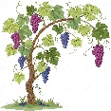
Mini Grapevine

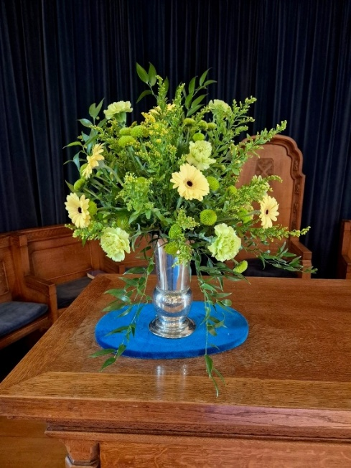
The flowers in the Church on Sunday 30th September were given by Caroline Gardner for her brother.

ArtPeace and Friends
Hard copies of the September article are now available in The Gateway. A colourful issue featuring the usual mix of stories showing the resilience of Zimbabweans where protest against an uncaring government is futile.

Treble Clef Choir

Gwenda and Hilary are both members of the Treble Clef Choir and have some tickets for this event on 9th October. Please see one of them if you are interested.

From the Foodbank:
I am writing to thank everyone at your church for your continued support of the Walton & Hersham foodbank through your generous donations of much-needed food and essential items.
We are incredibly grateful for your support which has enabled us to help local people facing hunger and hardship, offering practical support and hope when it is needed most. Thank you for being part of this work.
Last year, with the help of supporters like you, we provided emergency food support to 3,096 adults and 2,372 children across our local community. To meet this need, we distributed more than 29 metric tonnes of food. Sadly, however, with the increasing costs of living especially in our borough, increasing numbers of people are struggling to make ends meet, and we are now supporting over 200 people each week across our food projects the Foodbank and Pantry. Our food stocks are currently at a concerning 1.7 tonnes which is a record low.
Behind these numbers are real people and families.
"Sarah" came to the foodbank after losing her job and struggling to cover essential household bills. With no money left for food, she was referred to us for emergency support. Thanks to donations from local churches, schools and community groups, we were able to provide food, practical help and a listening ear during a very difficult time.


As in previous years, we will, once again, be supporting the Link to Hope appeal. The Link to Hope Shoebox Appeal 2026 brings practical help, dignity, and hope to families and elderly people living in poverty across Ukraine and Eastern Europe — not just children. We ask that you fill a shoebox with a carefully selected mix of practical and thoughtful items for all family members, including toiletries, stationery, family games, gifts for mum and dad, sweets, soft toys, and seasonal essentials such as hats and scarves. These boxes will be collected at our service on 25th October.
Please help transform lives across Ukraine and Eastern Europe — one shoebox at a time!
