ST ANDREW’S UNITED REFORMED CHURCH, WALTON AND WEYBRIDGE


Sunday 9th 2026
Morning Worship
led by Alison Sage

WE EXTEND THE WARMEST OF WELCOMES
TO ALL VISITORS
New to the Church? Do make yourself known to us!

Prayer before services: some useful personal prayers are to be found on the inside front cover of the hymnbook.

Come to the Edge by Christopher Logue

Come to the edge.
We might fall.
Come to the edge.
It’s too high!
COME TO THE EDGE.
And they came,
And he pushed,
And they flew.

(From The Poetry Pharmacy, William Sieghart)

Order of Service

Call to Worship

Hymn 531 Lord of all hopefulness

Prayers

Lord's Prayer

Family time

Introduction to the theme

Hymn 629 Make me a channel of your peace

Reading: Romans 10:5-15 (Page 148 NT)
Reading: Matthew 14:22-33 (Page 15 NT)

Hymn 268 Jesus is Lord! Creation’s voice proclaims it

Sermon

Hymn 474 Brother, Sister, let me serve you

Prayers of Thanksgiving and Intercession

Hymn 492 Dear Lord and Father of mankind

Blessing

Sung Amen

Exit of the Bible

Service Diary

Sunday 16th August 10:30 Morning Worship
Led by Vivien Gerhold

Sunday 23rd August 10:30 Morning Worship
Led by Elders

Sunday 30th August 10:30 Morning Worship
Led by David Paterson

Sunday 6th September 10:30 Morning Worship
With Holy Communion
Led by Stephen Thornton

Notices


Copies of the latest ArtPeace (Zimbabwe) article are now available in the Gateway. Please do pick one up on your way out today for an update on our friends in Zimbabwe. (More ArtPeace news in the Mini Grapevine)

St Andrews Coffee Morning 

Thank you to all who came along to the coffee morning on Tuesday 4th August. It was well supported by St Andrews and hopefully word will spread to the local community.


Mini Grapevine

The flowers in Church today are given by Anne Fitzgerald to celebrate the wedding anniversaries of her children.

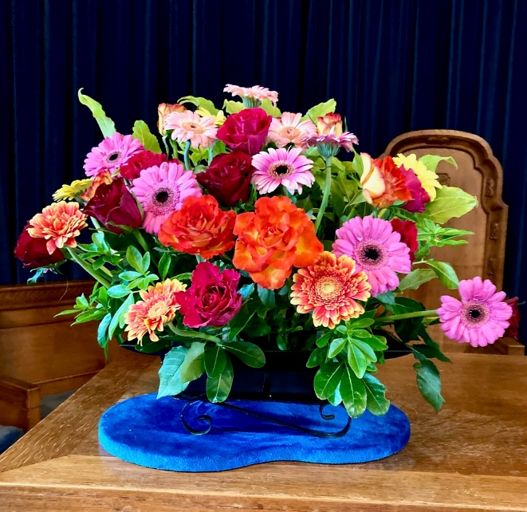
The flowers in the Church on 26th July were given by Paula Walsh for her mum’s birthday.

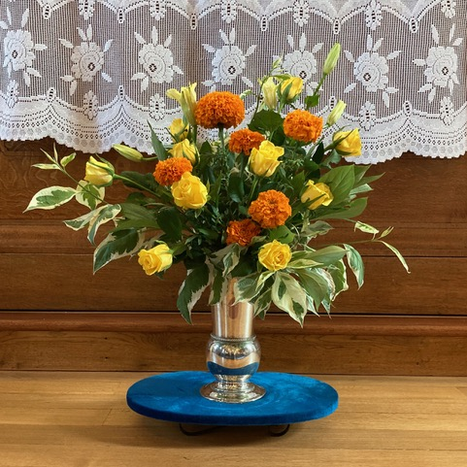

The flowers in Church on 2nd August.

Walton and District Allotment & Garden Society Summer Show

This annual show will take place in our hall on Saturday 22nd August from 2pm with refreshments (a few of our congregation are members). There will also be a few interesting stalls in the Garden Room and Artpeace will probably feature attracting a different audience. The show is usually stunning and hopefully, this long drought won’t affect exhibits too much this year.

WALTON AND DISTRICT ALLOTMENT AND GARDEN SOCIETY
LATE SUMMER SHOW

Show opens at 2pm
Trophies and awards will be presented from 4pm

For more information or if you are interested in exhibiting, please email
Showsecretary.wadags@gmail.com

ArtPeace
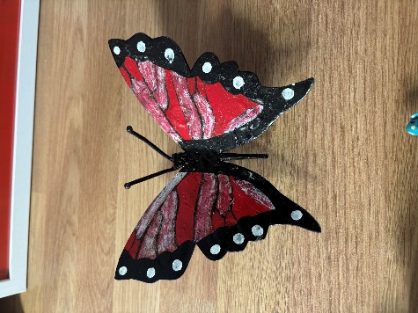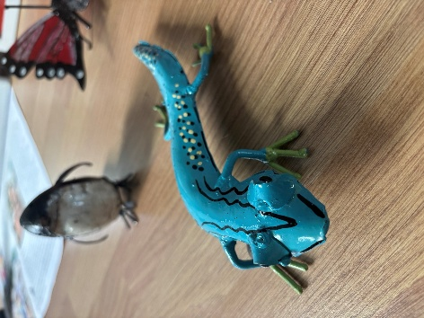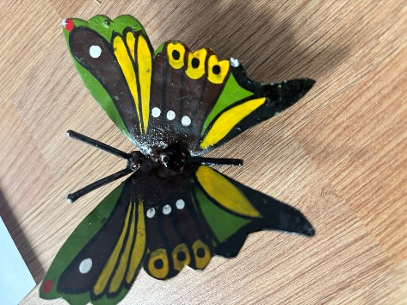
In the Gateway are some samples of some metal hand painted crafts by Knowledge Chitome. These and more will be available for sale in September. It’s so nice to have a variety of work with the paintings that we received recently still available to view and the usual sculptures.

Johnston has received a heartwarming video from the Sunday School who can be seen reading from the Bibles that our donations helped to buy. Mike Masedza sent a message to say: ’Hi John, there was a big turnout at our Sunday School yesterday. Netsai my wife, said the bibles are proving very popular - few families possess any books at home’.

Room Hire update

The Elmbridge Borough Council has announced several changes to its community centres, including temporary closures and transfer of ownership to local charities.
This is causing a lot of uncertainty to the hirers of these centres who are unsure about their future at these venues.
As a result, many have reached out to us and we have been able to help the following groups with temporary or permanent accommodation:

The Repair Café – A temporary move for August
Usually held at Walton Centre for the Community

Bridge Club – A temporary move for August

Strength and Balance Class – A permanent move

Counselling Sessions – A permanent move

Baby Massage Classes – a temporary move for the summer

Enquiries have also been made by Walton Art Club.

Voices for Hope are the Charity that have taken over the day to day running of Walton Centre for the Community and have reached out to us for information about any drop in coffee mornings that we run so that they can add us to their portfolio of local events.

You can also follow us on Facebook:
https:www.facebook.com/standrewsurcww

All Church information can also be found on our website:
www.standrewsurc.org

Interim Moderator: The Revd Peter Flint

FOR ANY ENQUIRIES PLEASE CONTACT THE CHURCH ADMINISTRATOR

