ST ANDREW’S UNITED REFORMED CHURCH, WALTON AND WEYBRIDGE

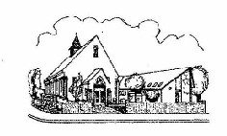
Sunday 23rd 2026
Morning Worship
led by The Elders

WE EXTEND THE WARMEST OF WELCOMES
TO ALL VISITORS
New to the Church? Do make yourself known to us!

Prayer before services: some useful personal prayers are to be found on the inside front cover of the hymnbook.

Keep your face to the sunshine and you cannot see a shadow.”
— Helen Keller

The flowers in the Church this week have been given by Rosemary Topping for her 60th Anniversary

Order of Service - Theme: Who do you say I am?

We are grateful to URC Devotions Team and the Revd Tafadzwa Kasere for permission to use this service.

Light the Peace Candle
Call to worship
Hymn R&S 492 Dear Lord and Father of mankind
Opening prayers

Hymn R&S 92 Amazing grace

Family Time

Bible Reading St Matthew 16 vv13-20 (p17 NT)

Hymn R&S 355 Jesus calls us o’er the tumult
Sermon
Hymn R&S 600 Christ is the world’s Light

Prayers of Intercession followed by the Lord’s Prayer
Hymn R&S 558 Will you come and follow me
Blessing followed by a sung Amen

Exit of the Bible

Service Diary

Sunday 30th August 10:30 Morning Worship
Led by David Paterson

Sunday 6th September 10:30 Morning Worship
With Holy Communion
Led by Stephen Thornton

Sunday 13th September 10:30 Morning Worship
Led by Katrina Clifford

Sunday 20th September 10:30 Morning Worship
Led by David Paterson


Mini Grapevine

Have you been wondering what this new green cabinet is in the car park?
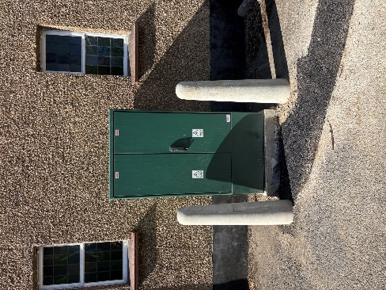
Well…it’s a current transfer chamber which has been installed with a new electricity meter for the Church. Last week, the car park was dug up, a trench dug from the chamber to the road and the electricity meter connected to the mains. It should have been as simple as that but it seems that the cabinet can’t now be connected to the meter because there is not enough space. Another cabinet needs to be installed so we wait again….
ARTPEACE & FRIENDS

There is great excitement in the Masedza household as work on a well has begun. This work has been financed with our donations.
Explosives had to be used to move large boulders 5 meters down but there is no water yet. Full details will be in the next Artpeace and Friends article.
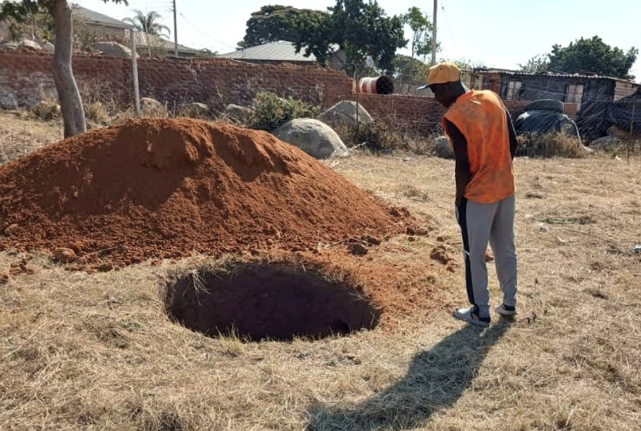

A reminder that should anyone wish to be added to St Andrew's email distribution list, let Johnston know. The September article will be issued shortly covering various aspects of life in Zimbabwe and the many photos taken by the artists appear far more vividly online. A few hard copies will continue to be available in the Gateway.

You can also follow us on Facebook:
https:www.facebook.com/standrewsurcww

All Church information can also be found on our website:
www.standrewsurc.org

