ST ANDREW’S UNITED REFORMED CHURCH, WALTON AND WEYBRIDGE


Sunday 16th 2026
Morning Worship
led by Vivien Gerhold

WE EXTEND THE WARMEST OF WELCOMES
TO ALL VISITORS
New to the Church? Do make yourself known to us!

Prayer before services: some useful personal prayers are to be found on the inside front cover of the hymnbook.

"A man cannot be measured by the colour of his skin, or by his speech, or by his clothes and jewels, but only by his heart. “
from 'Sinuhe the Egyptian' by Mika Waltari

The flowers in the Church today have been given by
Liz Grimsey in memory of good friends

Order of Service

Entry of the Bible

Notices and Lighting of Peace Candle

Call to Worship

Hymn 117 O Lord my God, when I in awesome wonder

Prayers and Lord’s Prayer

Family Time

Hymn 353 There’s a wideness in God’s mercy

Readings: Genesis 45: 1 – 15 (Page 39 OT)
Matthew 15: 10 – 28 (Page 16 NT)

Sermon

Pause for reflection

Hymn 474 Brother, Sister, let me serve you

Prayers of Intercession

Dedication of Offerings

Hymn 647 In Christ there is no East or West

Blessing

Service Diary

Sunday 23rd August 10:30 Morning Worship
Led by Elders

Sunday 30th August 10:30 Morning Worship
Led by David Paterson

Sunday 6th September 10:30 Morning Worship
With Holy Communion
Led by Stephen Thornton

Sunday 13th September 10:30 Morning Worship
Led by Katrina Clifford


Mini Grapevine

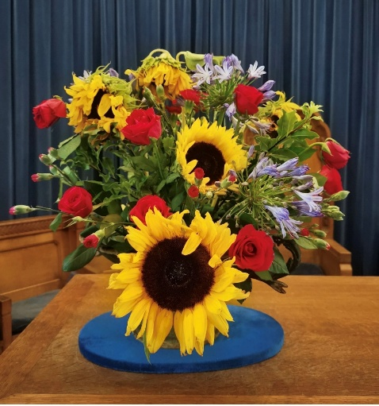
The flowers in the Church on 9th August were given by Anne Fitzgerald.

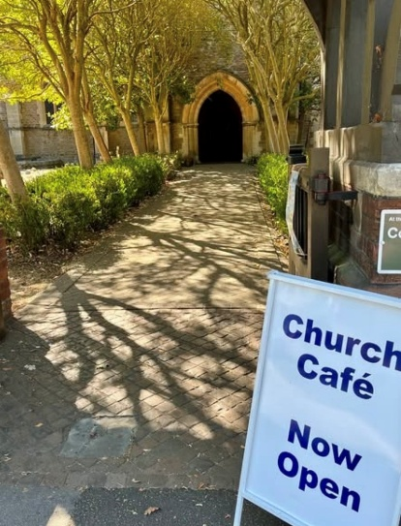
A new community café has opened at St Peter’s Church on a Wednesday from 10am-12pm. It offers simple refreshments and a comfortable and welcoming environment

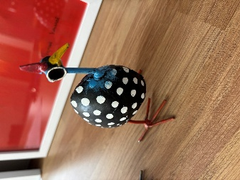
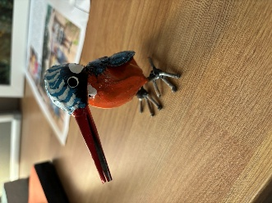
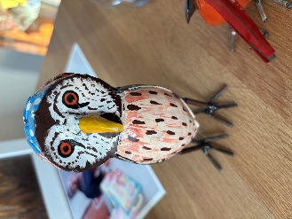
A few more metal ArtPeace pieces have arrived in The Gateway – do have a look.

The Repair Café

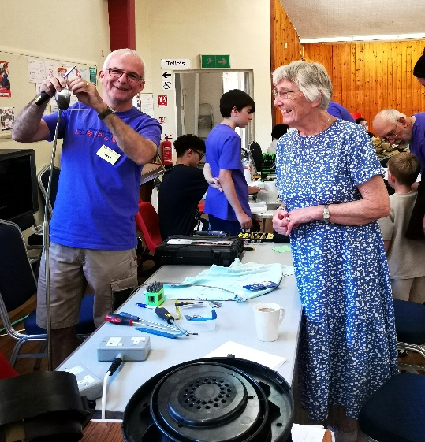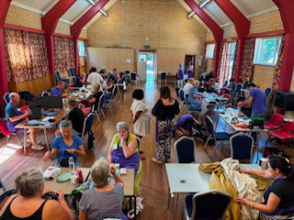
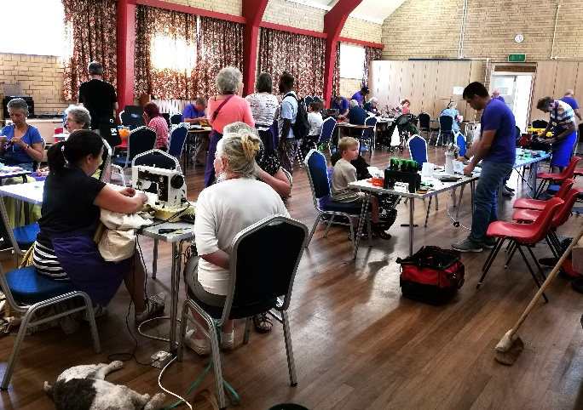
Look how full the hall was for the Repair Café last Saturday!
They had to temporarily move from their usual location for August and came to us.
A day full of volunteers fixing items that would otherwise go to landfill. There were electrical items being tested, parts replaced or simply cleaned and fabric items being sewn, patched or repurposed.
Anne Fitzgerald and Johnston Simpson were there to see what it was all about and to show people around our building. Sue Cooper from the Repair Café sent an email to thank them and to say how lovely our venue is. She said that the repairers and customers were all very happy. Anne sent the following report:

When I heard the Repair Shop was coming to St Andrew’s I got quite excited. Years ago they were wonderful in repairing the hand set for Keith’s riser chair after we had purchased several replacements and contacted the manufacturer with no results. I took the original to them and they carefully cut through the wire and soldered the parts together, a repair which is still in use today.

I wondered what I could take and remembered the lamp now in the garage waiting to go to the tip. It was much better looking than its replacement. I booked a place, got a time and took it along. Within minutes it was no longer wobbly, lit up and was back to its former self . I was so pleased.

I did not realise what a busy event this is. We entered through the front hall door into the garden room where particulars were taken and forms signed. Next step was using the seldom opened door from there into the crowded hall for a pat test. Then we were allocated a repairer and went to his table. Tea and coffee with homemade cakes were served by Irene Allen, a member of St Andrew’s, at the hatch. Sitting in front of the stage were a group of knitters and someone with a sewing machine who looked as though she was repairing a pair of heavy curtains .

There were people bringing varied items. I saw record players, fans, vacuum cleaners, children’s toys and lawn mowers. Most people went off with smiles but a few items were beyond repair.

The organisers were thrilled with St Andrews’ facilities, reckoning they were the best they had encountered and are sad they cannot continue to come due to previous bookings. They are considering opening up on a Wednesday so we may have them again.

Walton and District Allotment & Garden Society Summer Show

This annual show will take place in our hall on Saturday 22nd August from 2pm with refreshments (a few of our congregation are members). There will also be a few interesting stalls in the Garden Room - Artpeace and Whistle Fish Cards among them. The show is usually stunning and hopefully, this long drought won’t affect exhibits too much this year.

WALTON AND DISTRICT ALLOTMENT AND GARDEN SOCIETY
LATE SUMMER SHOW

Show opens at 2pm
Trophies and awards will be presented from 4pm

For more information or if you are interested in exhibiting, please email
Showsecretary.wadags@gmail.com

You can also follow us on Facebook:
https:www.facebook.com/standrewsurcww

All Church information can also be found on our website:
www.standrewsurc.org

Interim Moderator: The Revd Peter Flint

FOR ANY ENQUIRIES PLEASE CONTACT THE CHURCH ADMINISTRATOR

