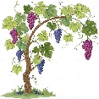
Mini Grapevine!

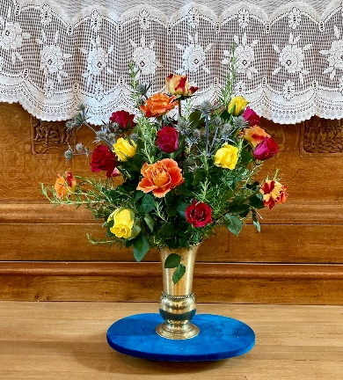

The flowers in the Church last Sunday were given by Alan and Anna Crawford for their wedding anniversary.

ArtPeace news

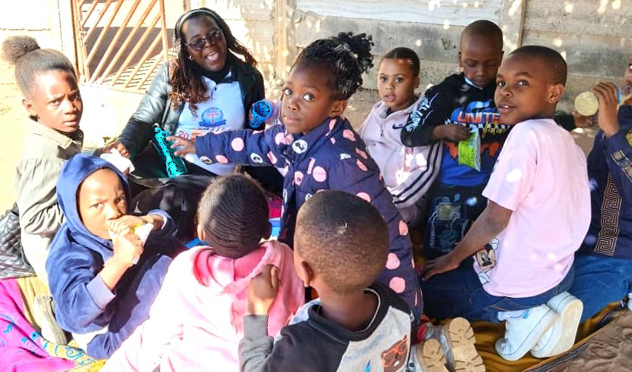
This is Netsai’s Sunday School Class. Netsai is the wife of Mike Masedza who is one of the artists. The children have no religious material and Netsai reads to them from the Bible. Last Sunday, two donations received from the congregation were quickly sent to Netsai so, as you read this, the children, the children will be happily using material bought on Friday.

The next ArtPeace article will feature news of Mike and Netsai’s visit to a remote part of Zimbabwe to visit her mother. Remote in Zimbabwe means that there is no telephone or means to stay in touch which makes our donations all the more worthwhile to cover their bus fares to visit family.
Eco News

This week’s question: Have you heard people say that climate change is natural and the earth will heal itself?’

Climate change is indeed natural but that doesn’t mean it can’t also be caused by human activities. The real lesson from past, natural, rapid climate change is that it produced significant extinctions. In other words, life got difficult.
The good news is that the fossil record shows that Earth always bounced back to full biodiversity. But this typically took 5-10 million years. Our planet will probably be fine again, but only after countless generations have had to survive on a severely damaged and far less beautiful world and what will the new planet look like?

If anyone would like to see the data, please visit www.netstupidzero.org


How’s everyone getting on with reducing plastic in July? If anyone has anything they’d like to share or tips for others, please let Elizabeth know: administrator@standrewsurc.org

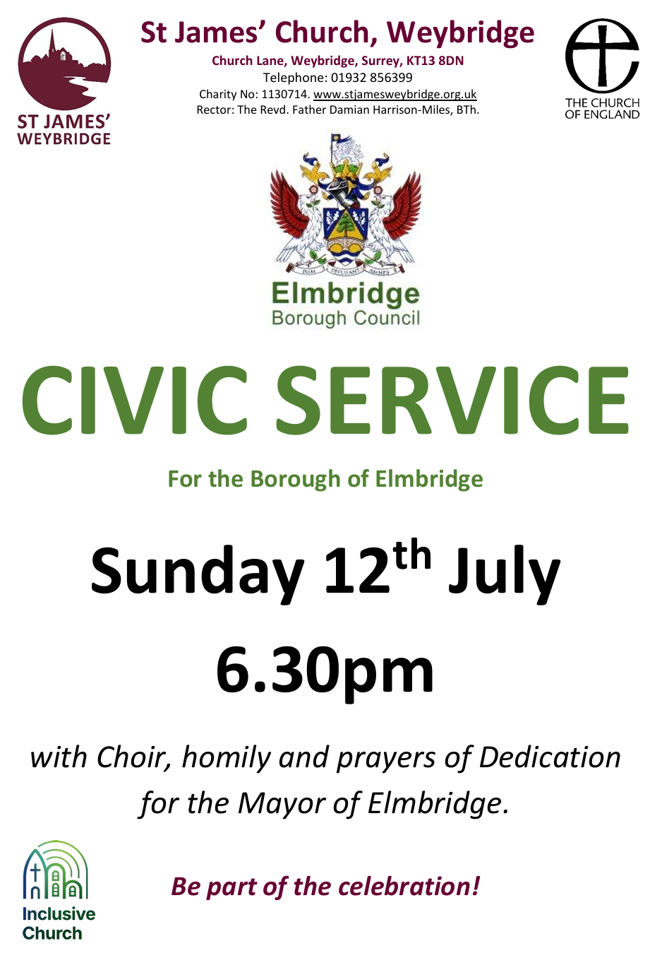

You can also follow us on Facebook:
https:www.facebook.com/standrewsurcww

All Church information can also be found on our website:
www.standrewsurc.org

Interim Moderator: The Revd Peter Flint

FOR ANY ENQUIRIES PLEASE CONTACT THE CHURCH ADMINISTRATOR

