ST ANDREW’S UNITED REFORMED CHURCH, WALTON AND WEYBRIDGE

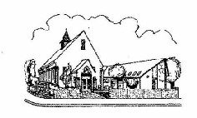
Sunday 26th July 2026
Morning Worship
led by Anna Crawford

WE EXTEND THE WARMEST OF WELCOMES
TO ALL VISITORS
New to the Church? Do make yourself known to us!

Prayer before services: some useful personal prayers are to be found on the inside front cover of the hymnbook.

“O Lord you know how busy I must be this day. If I forget thee, do not thou forget me.
- Jacob Astley, before the Battle of Edgehill, 1642



The flowers in the Church today have been given by Paula Walsh for her mum’s birthday

Service Diary

Sunday 2nd August 10:30 Morning Worship
With Holy Communion
Led by Mark Dennis

Sunday 9th August 10:30 Morning Worship
Led by Alison Sage

Sunday 16th August 10:30 Morning Worship
Led by Vivien Gerhold

Sunday 23rd August 10:30 Morning Worship
Led by The Elders

Notices

Elizabeth Scharinger will be on holiday from Tuesday 28th July, returning to the office on Thursday 6th August.

Order of Service

Notices

Call to Worship
Introduction to the theme

Hymn Sing to God new songs of worship
(See Attached)

Prayers of Thanksgiving, confession, assurance.

The Lord’s Prayer

Family time

Hymn 413 What a friend we have in Jesus

Reading Hebrews 12: 1-6 (Page 210 NT)

Hymn 495 Father, hear the prayer we offer

Reading Philippians 4: 4-9 (Page 184 NT)

Hymn 567 Thy Hand, O God, has guided

Reading Psalm 100 (Page 508 OT)

Prayers of intercession

Hymn 76 The Lord is King! lift up your voice.

Blessing and dismissal

Sing to God new songs of worship –
all His deeds are marvellous;
He has brought salvation to us
with His hand and holy arm,
He has shown to all the nations
Righteousness and saving power,
He has recalled His truth and mercy
To His people Israel.

. Sing to God new songs of worship -
earth has seen His victory;
Let the lands of earth be joyful
Praising Him with thankfulness.
Sound upon the harp His praises,
Play to Him with melody -
Let the trumpets sound his triumph,
Show your joy to God the King.

Sing to God new songs of worship -
Let the sea now make a noise;
All on earth and in the waters
Sound your praises to the Lord.
let the hills be joyful together
Let the rivers clap their hands,
For with righteousness and justice
He will come to Judge the earth.

M A Baughen


Mini Grapevine!


The flowers last Sunday were given by Anne Fitzgerald for Keith’s birthday and their wedding anniversary.


New Coffee Drop In

On Tuesday 4 August, we will be holding a coffee morning at the Church from 11am-12. This will be open to the congregation but also to the wider community, in particular the Voices for Hope charity who have just taken over Hersham Community Centre. This charity is keen to advertise any local events such as this for anyone to come along to for coffee/ tea, company and friendly chat. It would be great to have a good number from
St Andrews on our first session and although it’s a drop in and there is no need to book, if you feel able to help, do let Gwenda Cochrane, Claire Ward or Elizabeth Scharinger know. We hope that this can be become a regular event at St Andrews.

Messy Church July

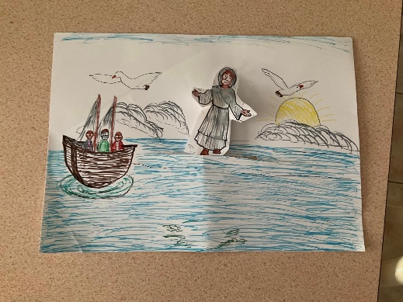
Last Sunday afternoon, the theme for the July Messy Church was Jesus walking on the water. The three toddlers all got on well and loved the water play and blue jelly!

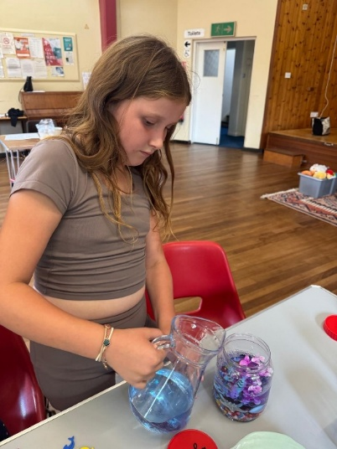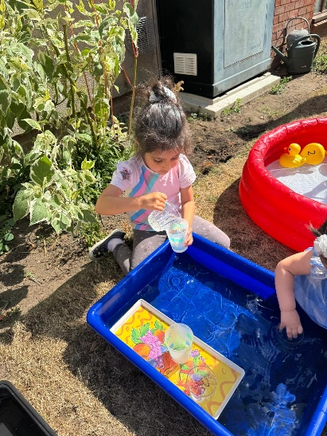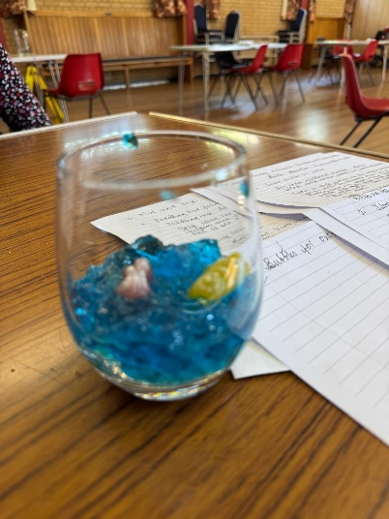
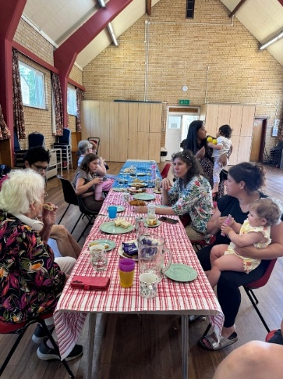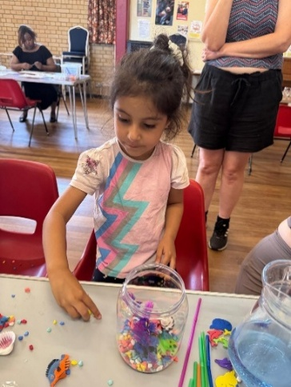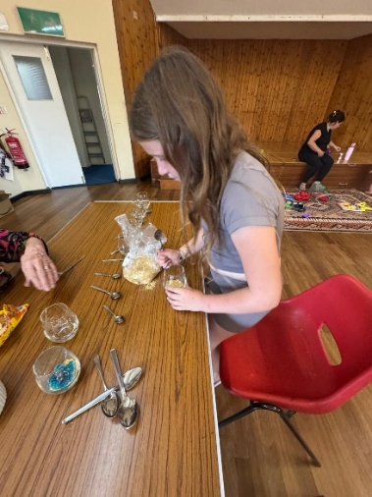



Repair Café coming to St Andrews for one day only!

On August 8th from 10am-1pm, the monthly Repair Café that is usually held at Walton Centre for the Community, is coming to St Andrews. Due to a refurbishment at the Community Centre, they have booked with us and would like as many people to come along as possible.

Do you know what a Repair Café is?

Repair Café is a worldwide network that aims to ensure that practical skills and shared and passed on and that things are used for longer and not thrown away.
Volunteer repairers are on hand to help fix electrical items, repair ornaments, mend toold, toys, furniture, bikes or patch up damaged clothes, replace buttons and much much more.

It’s all free but you must book in beforehand so that they know what to expect.

Please email repaircafewot@gmail.com or
phone 07933 619818 if you have something that is in need of repair.

You can also follow us on Facebook:
https:www.facebook.com/standrewsurcww

All Church information can also be found on our website:
www.standrewsurc.org

Interim Moderator: The Revd Peter Flint

FOR ANY ENQUIRIES PLEASE CONTACT THE CHURCH ADMINISTRATOR

