ST ANDREW’S UNITED REFORMED CHURCH, WALTON AND WEYBRIDGE


Sunday 19th July 2026
Morning Worship
led by Graham Pearcey

WE EXTEND THE WARMEST OF WELCOMES
TO ALL VISITORS
New to the Church? Do make yourself known to us!

Prayer before services: some useful personal prayers are to be found on the inside front cover of the hymnbook.

Bees work for man, and yet they never bruise
Their Master's flower, but leave it having done,
As fair as ever and as fit to use;
So both the flower doth stay and honey run.

- George Herbert

The flowers in the Church today have been given Anne Fitzgerald for Keith’s birthday and their wedding anniversary.

Service Diary

Sunday 26th July 10:30 Morning Worship
Led by Anna Crawford

Sunday 2nd August 10:30 Morning Worship
Led by Mark Dennis

Sunday 9th August 10:30 Morning Worship
Led by Alison Sage

Sunday 16th August 10:30 Morning Worship
Led by Vivien Gerhold

Order of Service

Entry of the Bible

Welcome and Notices

Lighting the Peace Candle

Call to Worship Psalm 130: 1-2, 5-7

Hymn 48 Praise and thanksgiving

Opening Prayer

Lord’s Prayer

Family Time

Hymn 590 In heavenly love abiding

Readings Romans 8: 12-25 (Page 146 NT)
Matthew 13: 24-30 (Page 13 NT)

Hymn 319 Thanks to God whose Word was spoken

Address

Hymn 538 Teach me, my God and King

Prayers of Intercession

Hymn 380 Christ, whose glory fills the skies

Dismissal and Blessing
Sung Amen


Mini Grapevine!

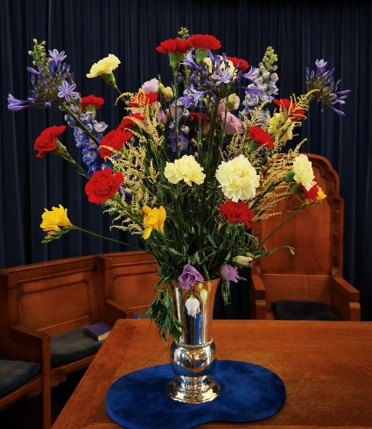
The flowers in the Church last week were given by Jean Rigden with love for John.

ArtPeace news


Last week, we reported that Netsai’s Sunday School class had no resources to learn from. Thanks to some donations from our congregation, she was able to go and buy them some and this picture is the class with their new Bibles. For many, this is the only book they own.


New Coffee Drop In

On Tuesday 4 August, we will be holding a coffee morning at the Church from 11am-12. This will be open to the congregation but also to the wider community, in particular the Voices for Hope charity who have just taken over Hersham Community Centre. This charity is keen to advertise any local events such as this for anyone to come along to for coffee/ tea, company and friendly chat. It would be great to have a good number from
St Andrews on our first session and although it’s a drop in and there is no need to book, if you feel able to help, do let Gwenda Cochrane, Claire Ward or Elizabeth Scharinger know. We hope that this can be become a regular event at St Andrews.

Eco News

The Green Team hope that you have found the questions posed over the last few weeks interesting and helpful. The website www.netstupidzero.org, where the information comes from is worth a visit. It’s a very clear, easy to navigate website.


Summer

Things tend to go quiet over the summer and there is not so much news to report, so, if anyone would like to contribute to the Mini Grapevine, I’d love to hear from you. Here are a few ideas for the Mini Grapevine over the summer:
- Holiday photos
- News from any interesting places you visit
- Ideas taken from other Churches you may visit
- Summer recipes
- Reading book recommendations
- Nice walk recommendations
- Tips on how to keep cool!!

I recently went to Lille for the weekend and it was incredibly hot! I found a lovely cool Church to sit in for a while – Eglise Saint Maurice. The stained glass was beautiful and added a vibrant splash of colour to this sacred place. (Elizabeth)
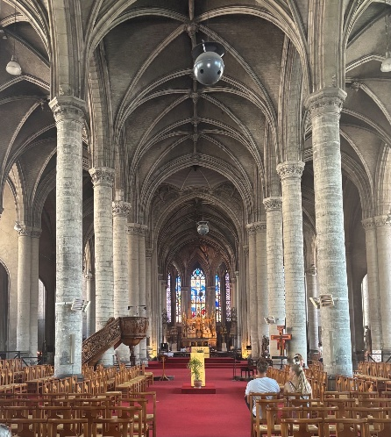

A Prayer for Summer
Loving God,
We thank you for the gift of summer—longer days, warm sunshine, gardens in bloom, and the beauty of your creation. As we enjoy this season, help us never to lose sight of the One who created it all.
We pray for all who are travelling this summer. Watch over them on every journey by road, rail, sea, and air. Grant them safety, patience, and times of joy and refreshment with family and friends. May their holidays bring rest for weary bodies, peace for anxious minds, and renewed strength for the days ahead.
For those who stay at home, help them to discover moments of delight close by: in a quiet garden, a gentle walk, the laughter of children, or the kindness of neighbours. May they too know the blessing of rest.
We thank you for the warmth of the sun and ask that we may use this season wisely—caring for one another, looking after your creation, and taking time to appreciate the gifts you so generously provide.
We remember those for whom summer is not an easy time: those who are lonely, grieving, unwell, working long hours, or unable to afford a holiday. Draw near to them with your comfort, surround them with your love, and help us to be signs of your compassion and care.
Wherever this summer takes us, may we walk with you, find you in the beauty around us, and return refreshed in body, mind, and spirit, ready to serve you with renewed joy.
In the name of Jesus Christ our Lord, Amen

You can also follow us on Facebook:
https:www.facebook.com/standrewsurcww

All Church information can also be found on our website:
www.standrewsurc.org

Interim Moderator: The Revd Peter Flint

FOR ANY ENQUIRIES PLEASE CONTACT THE CHURCH ADMINISTRATOR

