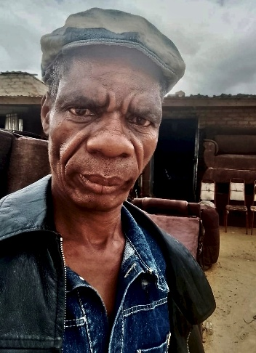
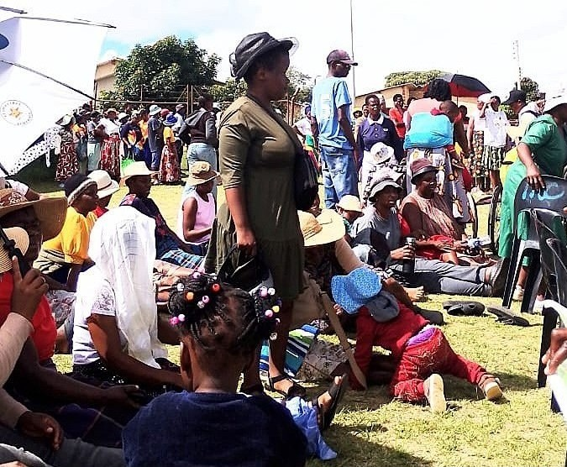
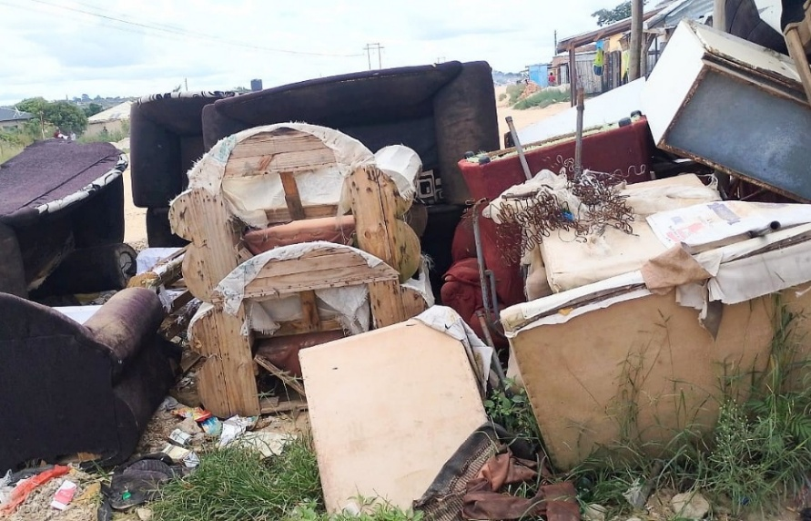
FORTUNE MASIYIWA is struggling to pay rent on his one room home. The second hand clothes he bought on a trip to Mozambique (covered by donations) covers three quarters of his rent due plus food, so he must try and find a better pitch to increase sales. In order to boost his income, his friend Alphonsus has agreed to teach him carpentry to repair dumped furniture or items brought in for repair. Fortune’s life continues to be one never ending struggle dogged by poor health. His eyesight is failing so he travelled eighty five miles by bus to Madziva to join hundreds of people (below) from all over Zimbabwe waiting for free eye examinations from European doctors who sadly failed to turn up.
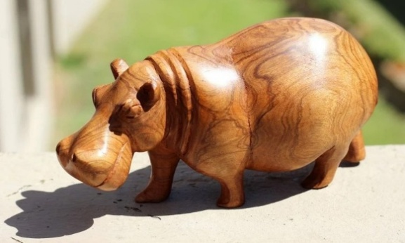
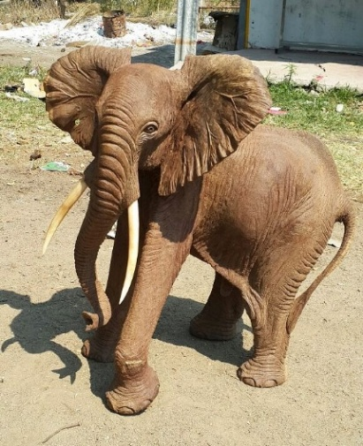
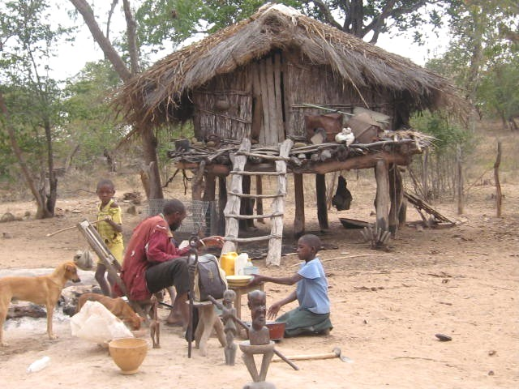
WOOD CARVINGS : Fortune is also considering visiting his friend Patrick Siajula in Binga in the north western part of Zimbabwe, bordering Zambia by the Zambezi River. His last trip was made on the back of lorries, returning with a sack full of tremendous wood carvings. Fortune first met Patrick whose lakeside home (right) on the south eastern shore of Lake Kariba, was built on poles giving protection against predators like crocodiles whilst providing good visibility to spot elephants which he frightens away through beating a drum to avoid damage to his field. A Binga carving (head) by an old tribesman can be seen in St. Andrew’s Gateway. However, I must calculate whether this trip would be cost effective and there is the ever growing problem of finding a traveller to take the carvings over to the UK.
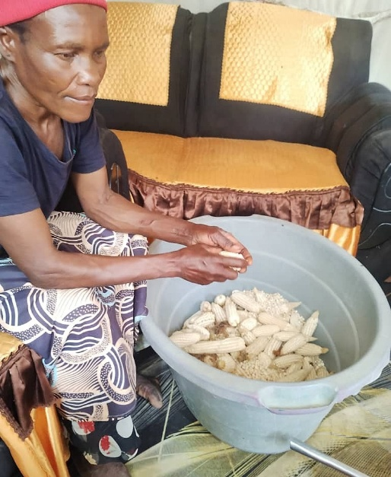
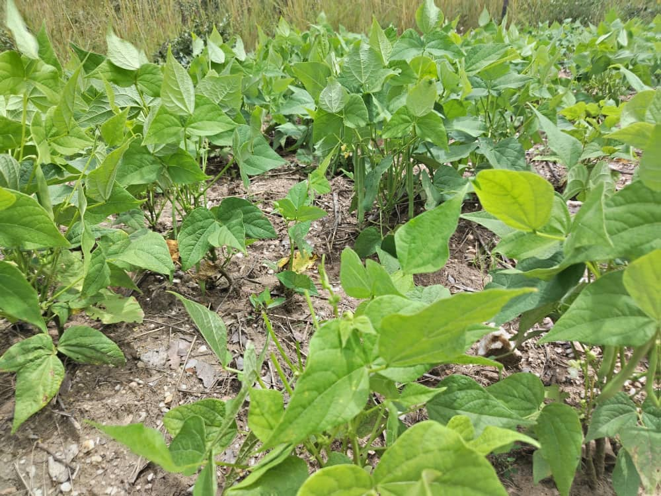
HARVEST TIME: Some of the artists have started harvesting their early sowings. Left, Coster’s wife Emma is removing maize from cobs which are taken to a grinding mill to turn into mealies.
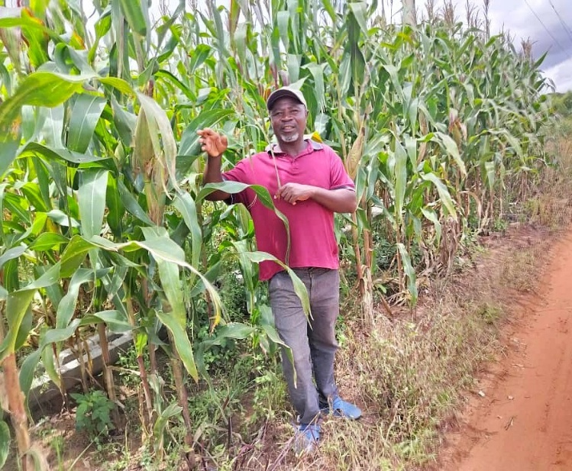
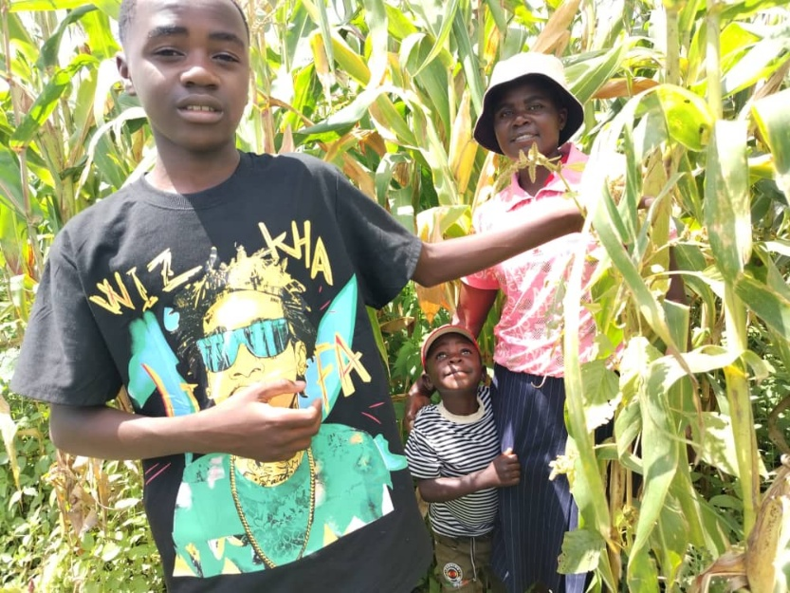
Below, Shingirai is delighted with his maize and sugar beans crops (above right). He thinks they will enjoy a better harvest than last year. Right: Wife Beauty and children Takudzwa and Tendai.
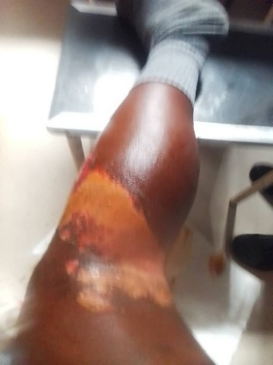
SHOCK: Lovemore was in agony when his old mobile burst into flames in his trouser pocket - chemical burns are nasty. He spent a night in hospital which could not provide any medication. He said: ‘I was forced to use my rent money to buy creams, bandages and painkillers from a pharmacy so that a nurse could dress my wound’.
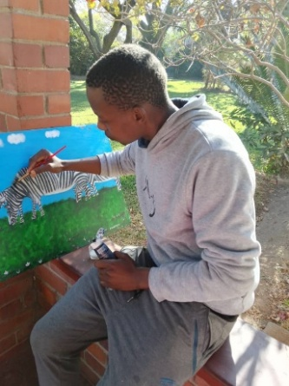
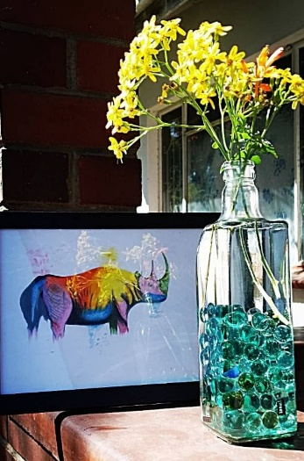
30 KGS OF SCULPTURES have arrived and will soon be on display and for sale in St Andrew’s Gateway and the Southwark Cathedral shop. Some painter friends of ArtPeace are keen to send their work for our approval. See the rhino on extreme right by 28 year old Winston, who is currently studying for a certificate in visual arts at the Zimbabwe National Art Gallery. Should there be enough interest, I may attempt to take a few paintings over. Johnston Simpson

