February 2025 | Eco Church  Stay up to date with our Eco Church Journey |  |  |  |  |  | Issue  #1
Where do I start?  There is so much information about the climate and the effect that climate change is having on the World, that it’s very easy to feel overwhelmed and bombared with too much information. It even has a name – ‘Eco Paralysis’.  Confliciting information – ‘Make sure you recycle’ vs ‘Recycling is costly’ or ‘Recycling takes energy’, should I be ‘Eco Friendly’ or ‘Sustainable’ or are they the same thing….?  In this first Eco Church article for The Grapevine, the Green Team which consists of Elizabeth Scharinger, Teresa Bacon and Paula Walsh, have decided to start with the basics and give you some easy wins for starting your Eco journey.  If you want any more information at any time, please do reach out to the Green Team and they will be very happy to help. |  |  |  | 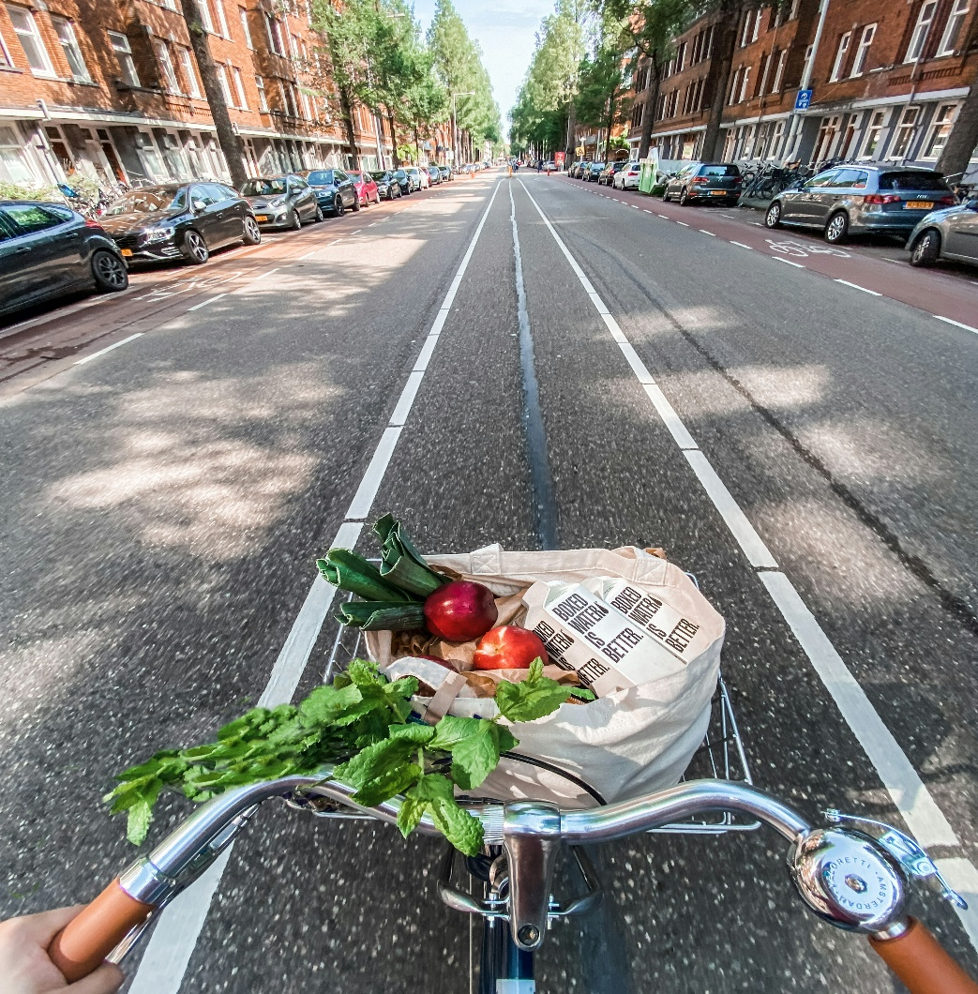
 |  |  |  | Picture Caption: The road to being Eco Friendly
Easy Eco Wins
We challenge you to do at least one of these before the next edition.
 |  |  |  | - Drive less – think about car sharing when you go to Church or the shops. Maybe take public transport more.  - Make one swap in your home from a chemical based cleaning product to a non toxic version.  - Buy lose fruit and vegetables  - Use left over water from your kettle or when boiling vegetables to water your house plants (once it’s cooled down!).  - Use Eco mode on your dishwasher or washing machine  Let Elizabeth in the office know what you have done and how easy or difficult it was to do– administrator@standrewsurc.org  By getting your feedback, we can gain points for the Lifestyle section of the Eco Church Survey. |  | What is Sustainable Living?  A lifestyle that seeks to minimize an individual’s (or society’s) use of Earth’s natural resources
“While individual actions
alone may not solve climate change, they are an essential part of the broader solution” (Cup of Toast Lifestyle blog)
Isaiah 55:12  A vivid picture of earth rejoicing giving us inspiration to care for the planet. |  |  | Genesis 1:28  God grants humans ‘stewardship’ of the earth |  | Psalm 104: 24-25  ‘In wisdom you made them all’  Reveals the intentional design and careful planning that went into all aspects of creating nature

